# Overview

File Decompressor UI is an application that works in conjunction with the File Archiver software. From a business perspective, files are compressed using FileArchiver to make room for current file generation. In the course of Imbalance Market business it is sometimes necessary to restore some of these files and reprocess them with updated information. The previous approach was clumsy and involved a lot of time because unzipping one file at a time with a tool like WinZip was both inefficient and did not yield the correct results. Those results were the extracted file’s dates were set to when it was extracted not to the original date of the file. Decompressor UI is a tool that provides extremely easy access to the mass of files collected over years and enables the operator to quickly extract these historic file back to their original form including the create date, modified date and accessed date.

# Design

The application was designed to provide an easy, intuitive interface to allow a user to quickly extract files that were compressed and archived in various storage locations.

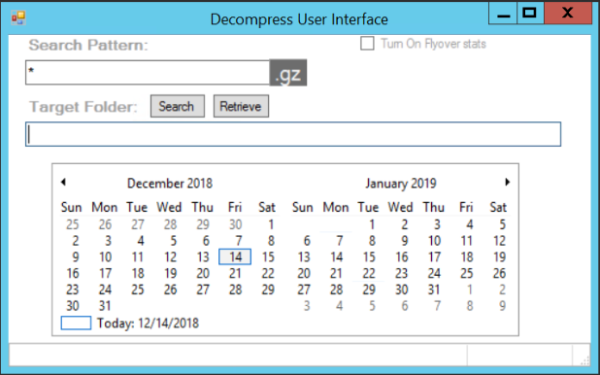

## Search Pattern:

The text box under Search Pattern allows the user to provide additional filtration of file names from the default value of “*”, all file names. The app only allows to the .gz extension, this is a GZIP compression algorithm and was selected because it required no licensing or fees, it was free.

## Search:

The search button provides the user a means of selecting the folder where the compressed files are located. It will open a folder selection dialog to make the desired selection.

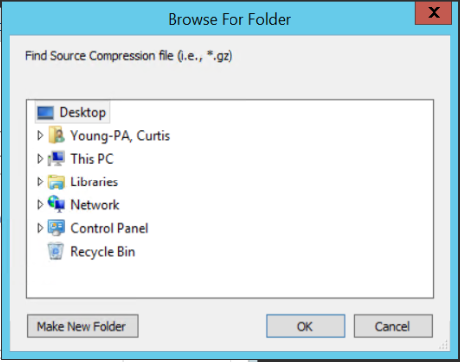

## Retrieve:

The Retrieve button will start the search for .GZ files in the folder shown in the Target Folder field. If no files exist that match the search pattern and have a .GZ extension then a message box stating no files found will alert the user.

If files are found then the app will set dates to bold on the calendar corresponding to the file’s creation date on that specific day. See Calendar for more information.

## Target Folder:

The target folder text box will be filled in when the user selects a folder and presses OK on the Browse for folder dialog.

The target folder can also be used as an initial starting place for the search button. By using a UNC path or simply a server name or CNAME and pressing Search, the Browse for Folder will open at the desired location.

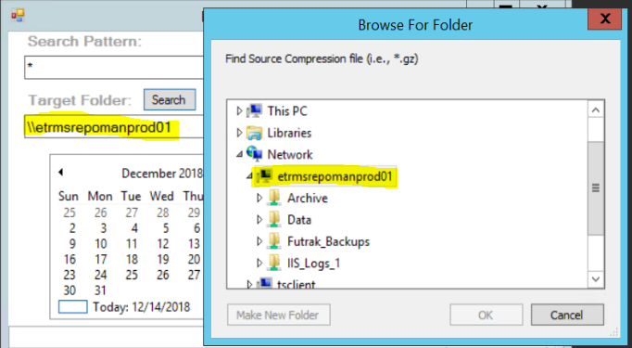

## Calendar:

The calendar was chosen for it universal intuitive conveyance of information. When selecting and retrieving the information, the application will read all files with extension of .GZ. More refined searches are possible using the Search Pattern.

Upon completion of the retrieve process, the calendar will scroll to the first date of any files created on that day. The dates are bolded for any file with create date found on that day.

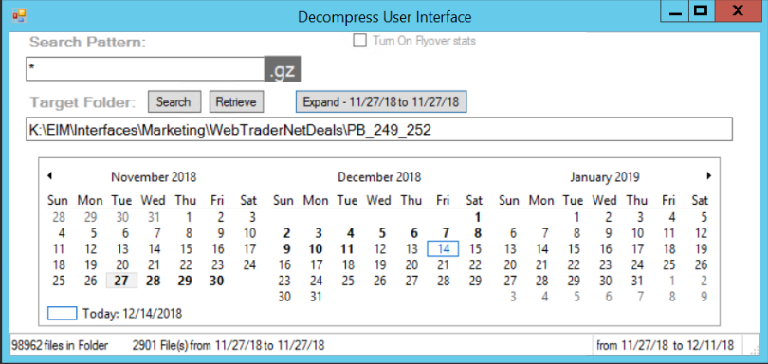

Note that the status bar contains information to the far left side of the total number of files. The far right panel contains the date range of all files those files.

If you select a day or a range of days, the app will display the total files selected and the selected date range.

An additional feature that will help in identifying files is the flyover file statistics. It displays a summary of files by their “subject area” giving a count of each type for the day under the mouse pointer. This is useful for identifying files of differing subject areas. Click on the Checkbox to Turn on Flyover stats.

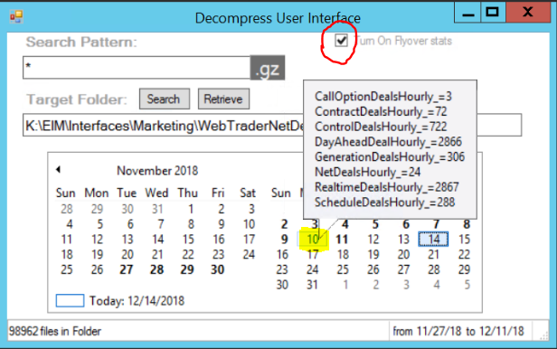

# Additional Details

You will notice that most every file’s name follows a particular pattern. The pattern is as follows:  
[subject area]_[YYYYMMDD]_[HHMMSS]...

The files are typically XML or CSV but any file type might be stored in the compressed GZ file.

There are a few scenarios that can be used to help focus on the files you want to extract. These are Search Pattern examples that are set before pressing the Retrieve button.

* Set the Search Pattern to the files “subject area” to isolate the files where file subject area are mixed.(i.e., NetDeal*)
* Set the Search Pattern to year and/or Month to get a smaller pull of files. (i.e., *_2017* or *201709*)
* Set a specific date and time for specific files the business wants. (i.e., *20170904_13*)
* Set a specific time of day (i.e., *_15*) for 3:00pm then use the calendar to select the desired date range for extraction.